

**SPORTS MANAGEMENT**

**Project plan**

**PRT 455 Software Engineering Practice**

HELEN JOSE CHITTOOPARAMBIL

(S288262)

Muhammad Ali Malik

(S289875)

Imran Khan

(s283021)

Table of Contents

1.1 Background 2

1.2 Aim 2

1.3 Scope 3

1.4 Objective 3

2. Product Description 3

3. Requirements 5

4. Design 6

5. Test Plan 7

6. Release Plan 7

7. Completed and Remaining Tasks 7

1. **Introduction**

## 1.1 Background

Arranging the sports and events can be tiresome and difficult process sometimes. The people are organizing the sports events through meetings and publishing them on different social Media. But these procedures are sometimes time and money consuming. To make the sports management and organization’s easy, we come up with a web application named sports management. The sport management is focused to allow the people to register different sports events, deciding venue and time for the sports and challenge others. Our application is not only focused on the individual persons but also the team can also join into it through registration and can perform the functionalities that a single person can. This also allow the people to book or buy the ticket for the sport events. The users can view the sport event page so that they can see which events are upcoming.

## 1.2 Aim

The aim of this project is to make a web based application called sports management. This application allows all the people to register into it and helping them to create sport events and selecting the venue and time. They also can challenge others for their sport event. The application not only focused on individual sport item but also focuses on the group. To make all this easier, the application allows the user to chat with each other and people can buy ticket through sports management.

## 1.3 Scope

The scope of this application is to help the user to identify the nearby sport events that they like and help the people to manage and organize the sport events without any meeting or publishing it into different places. By organizing the sports through this application, helps to reach maximum of audience. This application will provide the information so that the users can identify the events which are coming soon.

## 1.4 Objective

Develop a web application that satisfy the criteria and requirements by meeting the quality and timeline which are already planned.

## Product Description

* 1. **Product Perspective**

Sports Management system is supposed to be an open source. It is a web based system using client server model. Product perspective contains major product features, system interface, design and implementation constraints, dependencies and development process.

* 1. **System Interfaces**

System Interfaces includes user, hardware and software interfaces of the product.

* + 1. **User Interface**

The User Interface of sports management system shall be compatible to any internet browser such as Internet Explorer, Google Chrome, Firefox, Mozilla or Netscape through which user can access to the system.

* + 1. **Software Interface**

The user’s browser should be HTML5 compatible for a acceptable user experience.

* + 1. **Hardware Interface**

Since the sports management system must run over the internet, so hardware device should be enable with internet.

* 1. **Major Product Functions**
* User Account
* Cross platform support
* Sport Event Management
* Sport Challenge Management

Sport Team

Individual User

* 1. **Design and Implementation Constraints**

The system is provisioned to be built on the ASP .NET MVC framework which implements the model-view-controller pattern. SQL Database will be used for data exchange and data storage. SQL Database Management Studio will be used for data management in initial stages of development.

* 1. **Dependencies**

This application highly depends on type and version of browser being installed on the system.

* 1. **Development Process**

For the development of this application waterfall development methodology is being followed and version control management Github is used.

* 1. **User Characteristics**

User of Sports Management System must be familiar with internet or have basic knowledge of operating the internet and have access to it.

## Requirements

* 1. **Functional Requirements**
* The application should be web based
* User receive correct information about the sport events from the application.
* User will be able to understand the GUI easily.
* System functionality is improved for better performance.

|  |  |
| --- | --- |
| Requirement | Description |
| New user Registration and Login | User signup, sign in with new user credential, password forgot and reset options. |
| Post events | Post the new events with date and venue. |
| Challenge Participants | Challenge other users for the sport events. |
| Chat with others | Chat for allowing the users to communicate with each other’s to manage the sports. |
| Mange Group event | The people can also arrange group events by organising group within the users of the application. |
| Manage the application | Administrator will maintain the software quality |

* 1. **Non-Functional Requirements**
* Better response time between interfaces
* Required temporary memory to run the application
* Safety and security about the user information
* Speed and reliability of the application

## Design

* 1. **Architectural Design**

The Model View Controller of the project is shown by the following diagram. As we know the MVC is an architecture pattern which divides any project into three interconnected parts. Model is the central most component of the system which saves data which comes view and controller. View generate outputs according to the model. Controller acts a middle man between the model and view, it accept command both from server side and client side.

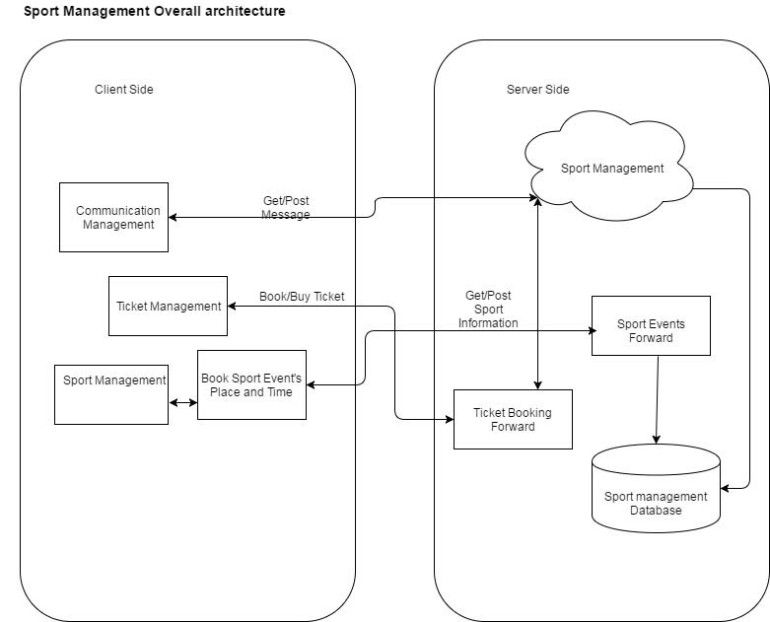

* 1. **Design Viewpoint 1: <State Diagram>**

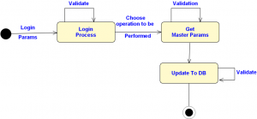

A simple state diagram is mentioned here to describe the dynamic behavior of this website. When an external user tries to login into this system it will validate the users by comparing it with the existing user list via database. If someone put wrong credential it can send a recovery password link to the email if the email is valid. In other case when user comes as external stimuli for the registration, the system check for the valid username and password if both fulfill the criteria then the system updates the database list with the username and password.

## Test Plan

System testing of sports management system will include user interface testing, use case testing and system unit testing. All features of application will be tested using suitable testing techniques and tools. For user interface testing black box testing technique will be used, all scenarios for this testing will be given in detailed document of Test Plan. For each use case there will at least two cases will be written one for pass scenario and one for fail scenario. Development IDE (visual studio) and internet browser will be used for use case testing. For unit testing test driven development (TDD) methodology will followed, for each system unit test code will be written before its actual implementation and visual studio IDE unit testing tool will be used for unit testing of system. Integration testing will also be used as we are developing our application into parts.



## Release Plan

Sport can be defined as activity involving the physical, mental and skill of an individual. We are proposing this website as open source especially for Australian. As we know Australian love sports and according to annual survey Australian Government about 82.3% of Australian takes part in physical activity at least once a year. Children participation is high, of every three at least two children participate in sports after school. Due to the participation, it has an overall effect on the international arena as per Olympic gold medal categories Australia has always remained in the top ten of the list. Sports like cricket, rugby tennis netball sailing and cycling Australian always has dominated their opponents. (Horton, 2015) However there are not many option Australian can choose when it comes to managing their favorite sports therefore we have plan this website in order to help peoples manage their favorite sport virtually. We feel it is a good opportunity for us as Australian government puts lot of money to sports sector and about 75,000 Australian are employed by this sector, one report of ABS shows 8.4 billion is spent by Australian Government to this Sector. if we can get good offer for that we can even commercialized this website and even will make an android app for the smart phones. This would be our privilege to offer such services to such an incredible sport loving nation and we are hope for the best in the future endeavor.

## Completed and Remaining Tasks

|  |  |  |  |
| --- | --- | --- | --- |
| **Task** | **Status** | **Weekly** | **Owned By** |
| User Account | Completed | Week 1 | Helen |
| User Login | Completed | Week 2 | Imran |
| Post an event | Complete | Week 3 | Ali |
| View Event | Ongoing | Week 4 and 5 | Imran |
| Post Challenge | Ongoing | Week 5 | Ali |
| View Challenge | Incomplete | Week 6,7 | Ali |
| Accept Challenge | Incomplete | Week 8,9 | Helen |
| Testing | Ongoing | 1,2,3,4,5 | All |
| Final version | Incomplete | 10,11,12 | Ali |

1. **References**

* Horton, P. (2015). The Governance of Sport in Australia: Centralization, Politics and Public Diplomacy, 1860–2000. *The International Journal of the History of Sport,* 1-24.
* Rowe, D. (2016). Cultural citizenship, media and sport in contemporary Australia. *International Review for the Sociology of Sport,* International Review for the Sociology of Sport, 04/22/2016.
* Wikipedia. 2017. The Model View Controller of the project is shown by the following diagram. As we know the MVC is an architecture pattern which divides any project into three interconnected parts. Model is the central most component of the system which saves data which comes view and controller i.e SQL server in this case.. [ONLINE] Available at: https://en.wikipedia.org/wiki/Model%E2%80%93view%E2%80%93controller. [Accessed 18 August 2017]

.